Elentine Step by Step ordering instructions.

Step 1: Go to www.elentine.com and click on “ORDER NOW”

Step 2: enter the name and password that was given to you in your Account Approved email and click on “Enter”

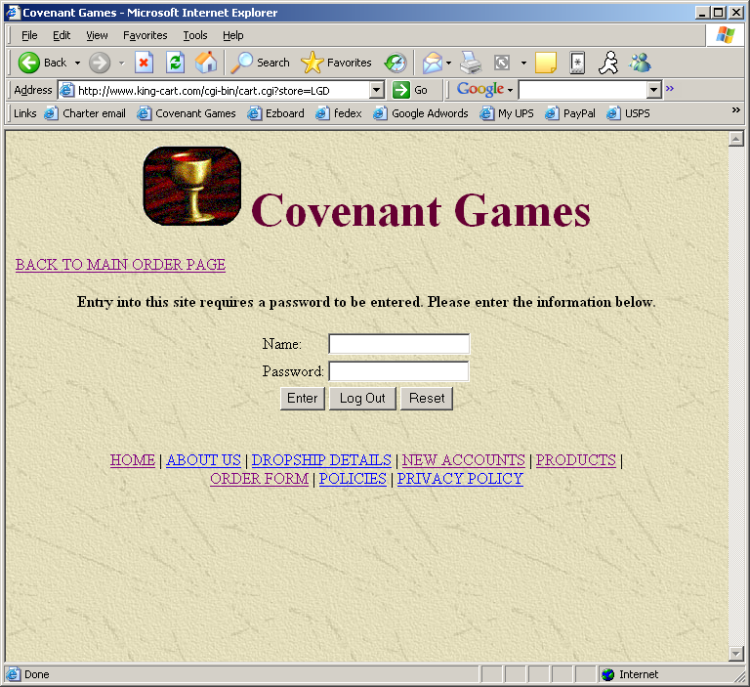

Step 3: Choose the category of the item you are ordering

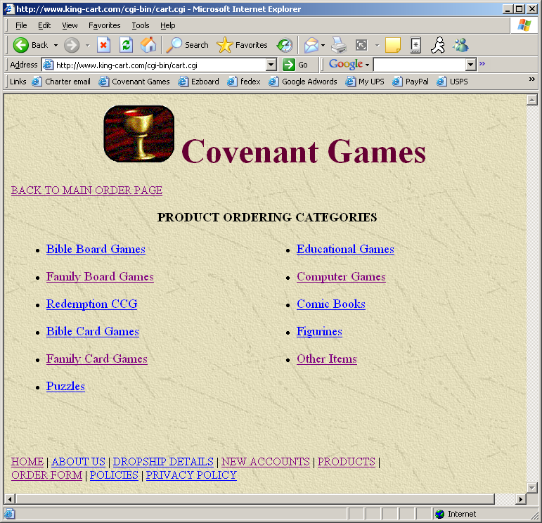

Step 4: Click “Add to Cart” for the item you are ordering. Repeat step 3 and 4 for each item on the order. When all items have been added, click on “Check Out”

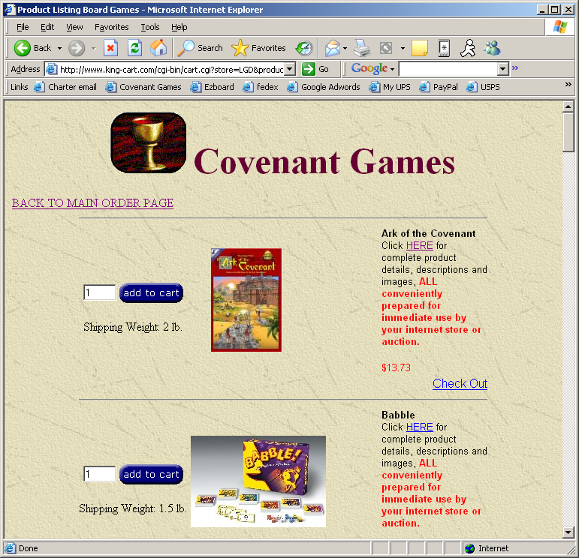

Step 5: Review your order, make changes if needed. IMPORTANT: your customer number is the username you used to log on, do not change it. If everything looks right, click on “Complete Order”

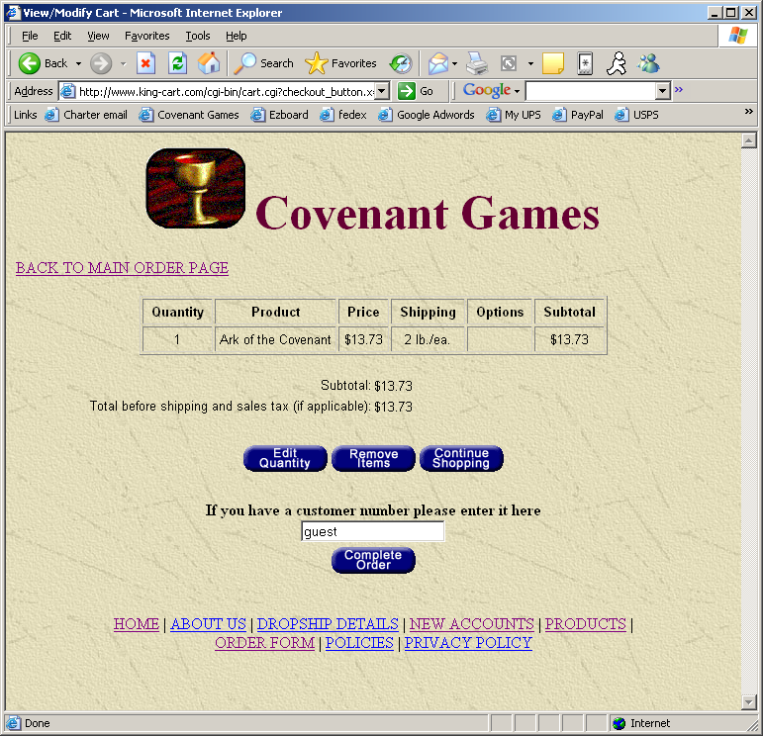

Step 6: Enter your company information in the Billing Address Section

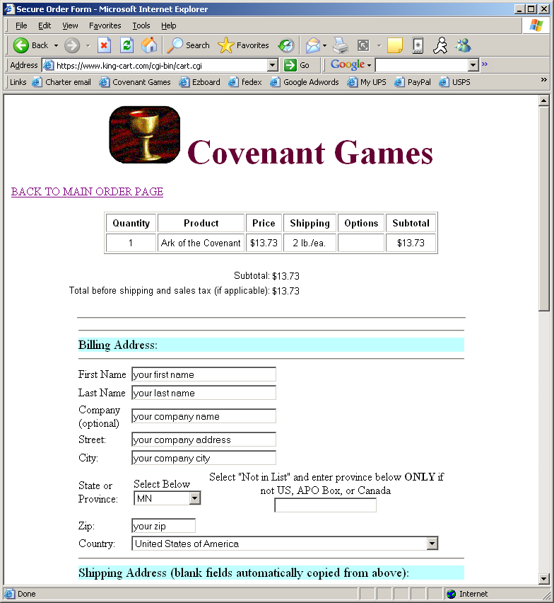

Step 7: Enter your customers information in the Shipping Address section. The company under this section is used only if your customer’s address includes a company name, otherwise, leave it blank. IMPORTANT: the email address in this section is the address that we will send your shipment tracking information to (this should be YOUR email address as a copy of your order with your pricing will be sent to it) When finished click on “Please Click Here to Continue”
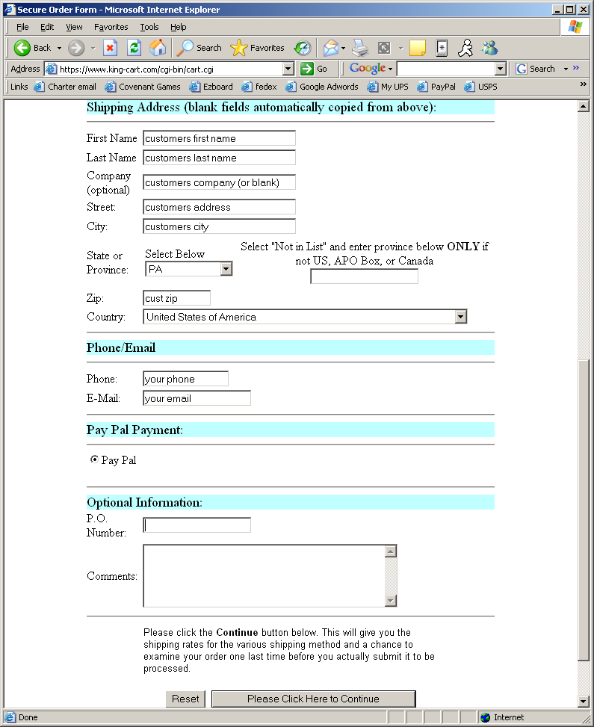

Step 8: Choose shipping method. Typically anything under 4 lbs will be cheaper to ship USPS Priority mail. Anything over 4 lbs will be cheaper via UPS Ground. We reserve the right to substitute the cheapest shipping method between USPS Priority Mail and UPS Ground on non-rush orders. When finished click on “Verify Order”
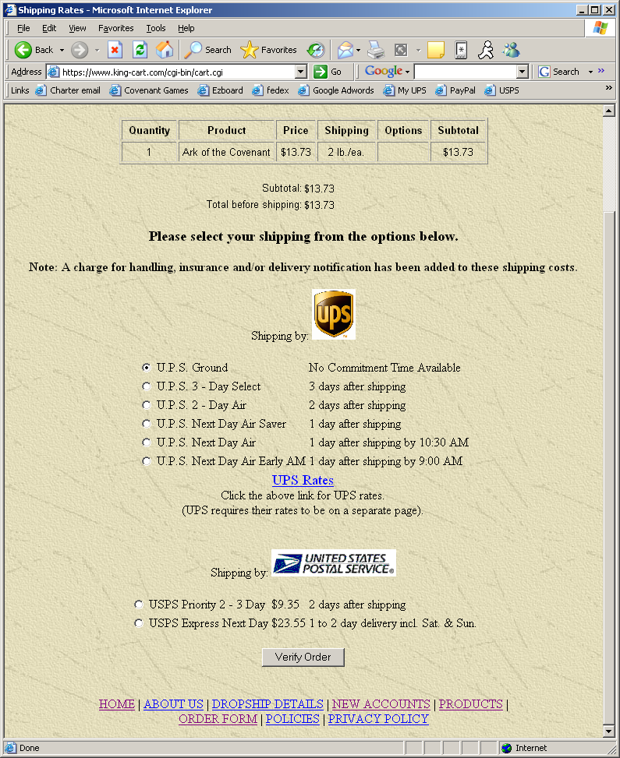

Step 9: Verify Shipping information. Then click “Click Here to Continue”
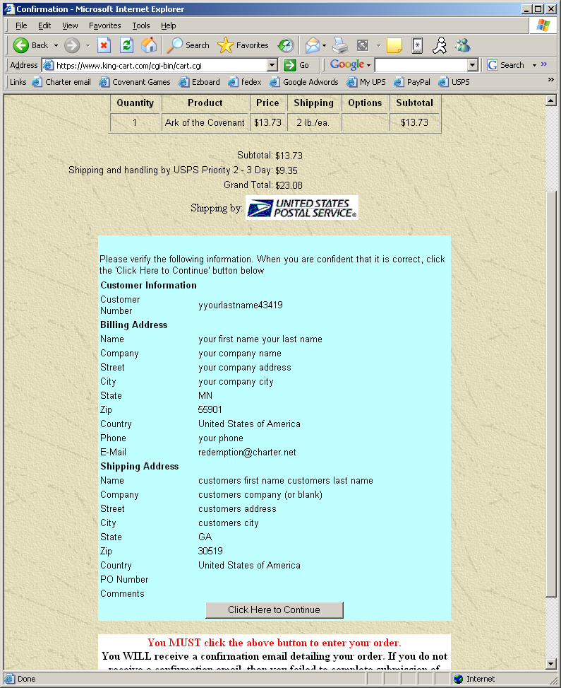

Step 10: Payment method. If you are paying via paypal, enter your account email and password and click continue. If you are paying with credit card, click on “Click Here”

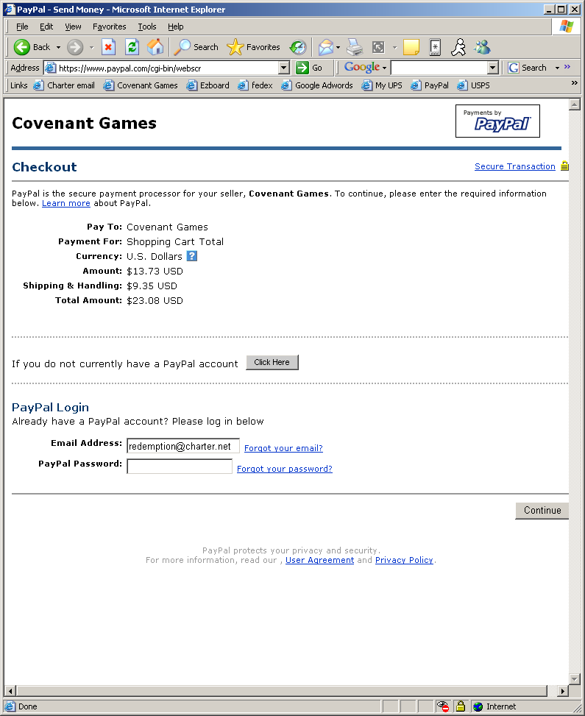

Step 11a (paypal payments only) review your information and click “Pay”

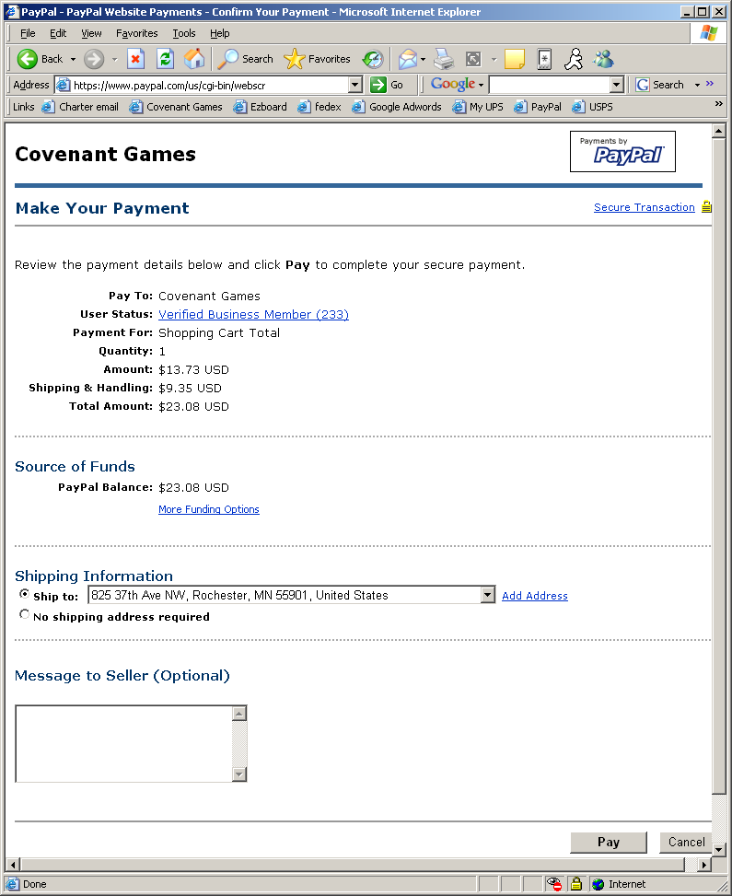

Step 11b: (Credit Card payments only) verify your credit card billing address and click “Continue Checkout”

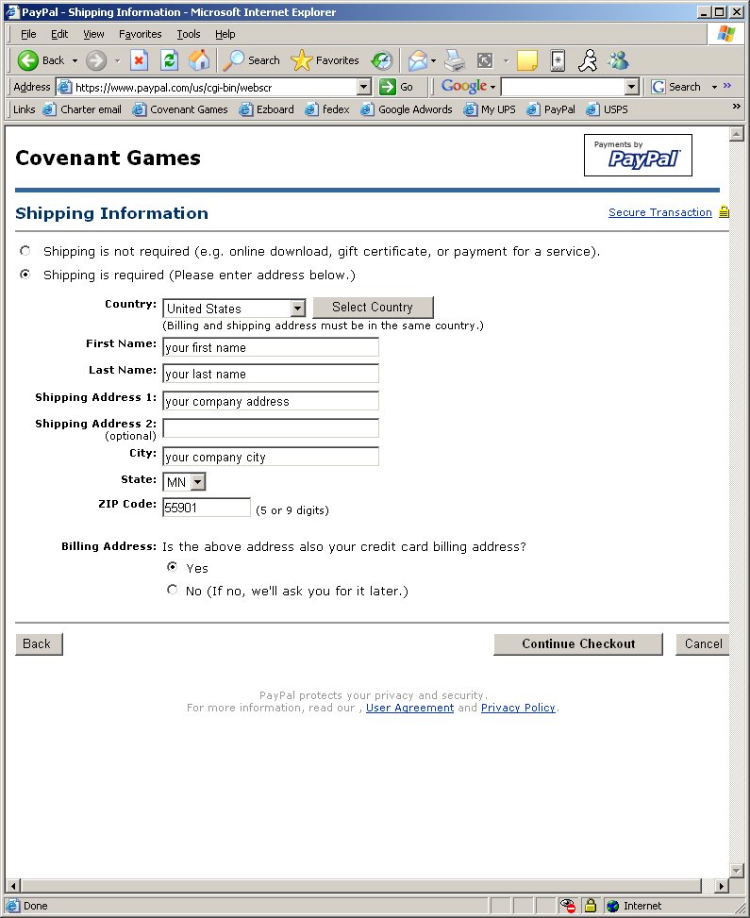

Step 11c (Credit Card Payments only) Enter your credit card information and click “Continue Checkout”

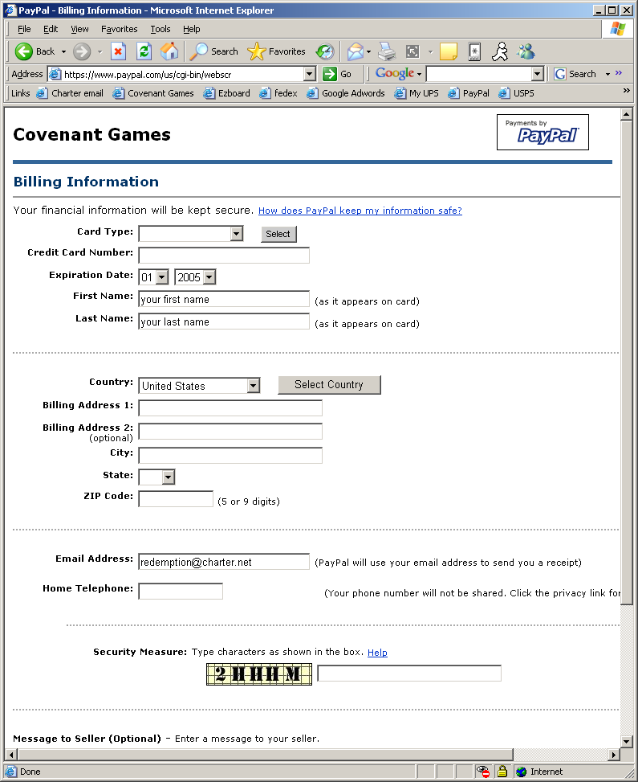

Step 12: Finish order. IMPORTANT: be sure to click “Continue” on this page or your order will not complete

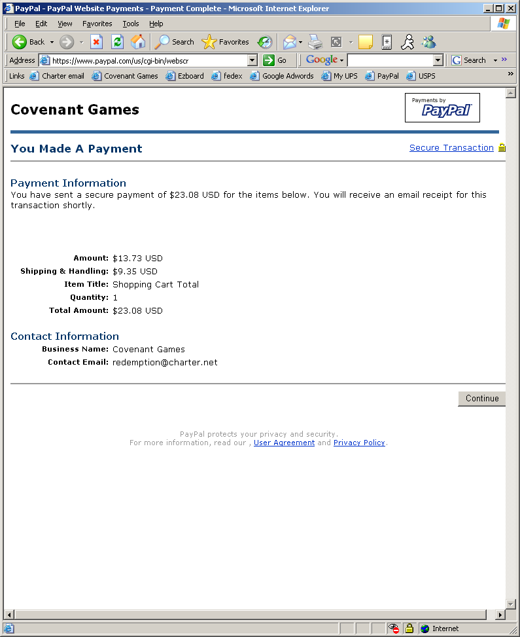

Step 13: You’re Done!!!

